

**Asia Pacific College**

**3 Humabon Place, Magallanes**

In Partial Fulfilment of the Requirements for the Subject

**System Analysis and Design**

**Linckt SCM System**

Submitted by:

Team Member’s Name:

**Rellosa, Philip John M.**

Project Manager

**Chua Jr., Antonio D.C.**

Research Writer

**Guzman, Franz**

Research Writer

Submitted to:

**Manuel Sebastian Sanchez**

Professor/Adviser

**Table of Contents**

I. Project Statement

1. Client Name

1.1 About Client

1.2 Organizational Chart

2. Project Statement form

2.1 Contact Information

2.2 Users

II. Project Description

3. Project Description

3.1 Project Objectives

III. Glossary

IV. Event Table

V. Use Cases

4. Use Cases

4.1 Use Case

4.2 Use Case Description (Full)

VI. Database Design

5. Database Design

5.1 Entity Relationship Diagram

5.2 Data Dictionary

VII. Diagrams

**I. Project Statement**

**1. LINCKT ENTERPRISES**

**1.1 About LINCKT Enterprises**

Linckt Enterprises is a type of buy-and-sell Company which supplies various preventive maintenance chemicals and lubricants to its clients which mainly are government industrial companies and big private industrial companies. Linckt Enterprises gets its products from either its external company manufacturer or from an US distributor. It is managed by Ms. Pinky Evangelista, the company’s general manager/owner. Linckt Enterprises office is located at Unit 8p tower1, TriBeCa km 21 east, Service Rd., Sucat Muntinlupa.

**1.2 Organizational Chart:**

**MS. MA. PILAR EVANGELISTA**

General Manager

**MS. JUDITH CALLO**HR/Admin

**MS. JANICE ONG**Accounting

**MR. ISHMAEL LIM**Liaison/Messenger

**MR. CELSO SOLAYBAR**  
Technician

**MS. GEMMA LARGADO**  
Sales Agent (Manila)

**MS. NURZAIDA VILLAGRACIA**  
Sale Agent (Mindanao)

# 2. Project Statement Form

## 2.1 Contact Information

|  |  |  |
| --- | --- | --- |
| Name | Position | Contact Information |
| Philip John M. Rellosa | Project Manager | [pmrellosa@student.apc.edu.ph](mailto:pmrellosa@student.apc.edu.ph),  [prellosa@yahoo.com](mailto:prellosa@yahoo.com) |
| Franz J. Guzman | Database Administrator | [fjguzman@student.apc.edu.ph](mailto:fjguzman@student.apc.edu.ph) |
| Antonio D. Chua Jr. | Analyst/Research Writer | [Adchua@student.apc.edu.ph](mailto:Adchua@student.apc.edu.ph),  Adchua1995@gmail.com |

**2.2 Users**

Target users are the company’s marketing, sales and accounting. The system makes them to be able to track their clients’ product consumptions and analyze and think possible actions and solutions needed by their client.

**II. Project Description**

# 3. Linckt Enterprise Supply Chain Management System

Linckt Enterprise Supply Chain Management will enhance the overall organization performance and customer satisfaction by improving product and service delivery to customers, providing a system for the client, supplier and for the management with the purpose of a faster and more systematic way of processing business transactions.

**3.1 Project Objectives**

Linckt Enterprise Supply Chain Management aims to make a more systematic and well coordinated system that stores updated data about list of transactions involving the three participants, this is solely designed for the management, supplier and client convenience.

**III. Glossary**

|  |  |
| --- | --- |
| Data flow diagram | A graphical representation of the step by step flow of data in a system.  Source: en.wikipedia.org/wiki/Data_flow_diagram |
| Use Case | A list of steps, typically defining interactions between a role (known in Unified Modeling Language  Source: en.wikipedia.org/wiki/Use_case |
| Event Table | A graphical representation of data in a tabular form, which contains different scenarios, this representation contains timing information about a specific events that takes place during a scenario.  Source:  https://www.neurobs.com/pres_docs/html/03.../03_event_table.htm |
| Database System | A database system is an organized collection of data, where users can store and modify the data entered. This is use to keep easily keep track of records.  Source: en.wikipedia.org/wiki/Outline_of_databases |
| Supply Chain Management | The strategic and well coordinated system for businesses involving supply management. The goal of SCM is to improve and prolonged a good performance of a company.  Source: en.wikipedia.org/wiki/SCM |
| Context flow diagram | A context diagram is a top level data flow diagram. It only contains one process node that generalizes the function of the entire system in relationship to external entities.  Source: www.smartdraw.com/resources/tutorials/context-diagrams/ |
| Purchase order or P.O | A purchase order or P.O is a commercial document and first official offer issued by a buyer to a seller, indicating types, quantities, and agreed prices for products or services.  Source: en.wikipedia.org/wiki/Purchase_order |
| Data Dictionary | 1. A set of information describing the contents, format, and structure of a database and the relationship between its elements, used to control access to and manipulation of the database.   Source: www.kettering.edu/offices.../information.../data-governance-committee |
|  |  |

**IV. Event Table**

**Client Event Table**

|  |  |  |  |  |  |
| --- | --- | --- | --- | --- | --- |
| Event | Trigger | Source | Use Case | Response | Destination |
| Client reads products of Linckt and creates purchase order | Client needs products | Client | Choosingof Orders | Purchase order’s information | Linckt |
| Client reads their transaction and transaction status | Waiting for the status of Clients and Linckt transaction | Client | Transaction Status |  |  |

**Linckt Employee Event Table**

|  |  |  |  |  |  |
| --- | --- | --- | --- | --- | --- |
| Event | Trigger | Source | Use Case | Response | Destination |
| Linckt Employee reads and confirms client’s orders | Client sends P.O. to Linckt | Linckt Employee | Reading and Confirmation of Orders | Client’s Purchase Order information | Client |
| Linckt Employee sends product request to the Supplier | Client’s Purchase Order | Linckt Employee | Product Request | Product Request Information | Supplier |
| Linckt Employee edits the order status of their clients | Product Request Response | Linckt Employee | Product Transaction Update | Order Status Information | Client |
| Linckt Employee creates or edits client’s payment status (official receipt) | Client paid their orders | Linckt Employee | Client’s Payment Status | Clients Official Receipt Information | Client |

**Linckt Administrator Event Table**

|  |  |  |  |  |  |
| --- | --- | --- | --- | --- | --- |
| Event | Trigger | Source | Use Case | Response | Destination |
| Linckt Administrator CRUD Users, Products, Linckt P.O. to their Supplier, their Client P.O, Delivery Status, Payment Status | Data Modification/Highest Privilege | Linckt Admin | Admin Privileges | System’s Data Informations | Linckt Admin |

**Supplier Event Table**

|  |  |  |  |  |  |
| --- | --- | --- | --- | --- | --- |
| Event | Trigger | Source | Use Case | Response | Destination |
| Supplier checks product request and edits product request status | Product status | Supplier | Product Request Response | Product Response Information | Linckt Employee |

**Use Case**

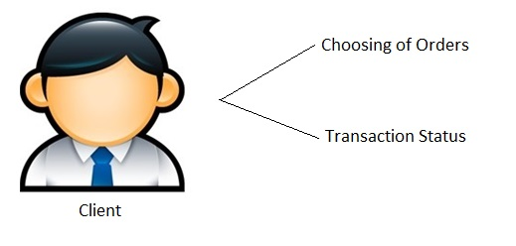

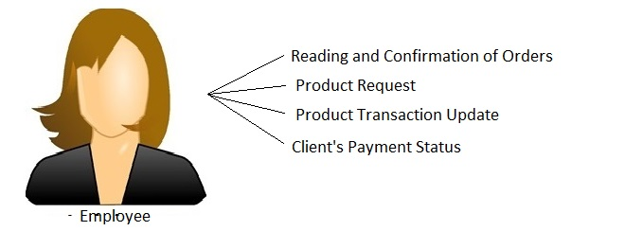

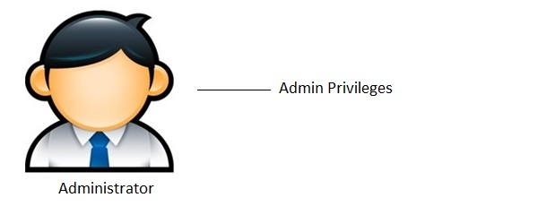

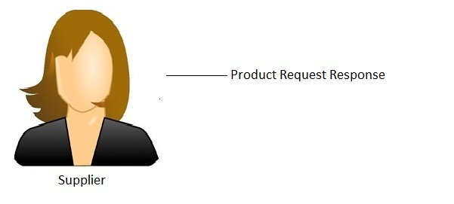

**Use Case (Full Description)**

Client

|  |  |
| --- | --- |
| Use Case Name: | Choosing of Orders |
| Scenario: | Client will choose orders |
| Triggering Event: | Client needs products |
| Brief Description: | Client will choose what to order |
| Actor(s): | Client |
| Stakeholder(s): | Company |
| Preconditions: |  |
| Post conditions: |  |
| Flow of activities: | Client reads the list of products of Linckt and creates purchase order |
| Exception conditions: | N/A |

|  |  |
| --- | --- |
| Use Case Name: | Transaction Status |
| Scenario: | Client peruse the transaction and its status |
| Triggering Event: | Waiting for the status of Clients and Linckt transaction |
| Brief Description: | Client checks its transaction and the status of it |
| Actor(s): | Employee |
| Stakeholder(s): | Company |
| Preconditions: |  |
| Post conditions: |  |
| Flow of activities: | Client reads the status of transaction |
| Exception conditions: | N/A |

**Employee**

|  |  |
| --- | --- |
| Use Case Name: | Reading and Confirmation of Orders |
| Scenario: | Linckt Employee reads and confirms client’s order |
| Triggering Event: | Client send P.O. to Linckt |
| Brief Description: | Linckt Employee peruse their client’s purchase order in the system |
| Actor(s): | Employee |
| Stakeholder(s): | Company |
| Preconditions: | Client sends P.O |
| Post conditions: | Linckt Employee sends product request to the Supplier |
| Flow of activities: | Linckt Employee will check the orders of the client and confirm client’s order |
| Exception conditions: | N/A |

|  |  |
| --- | --- |
| Use Case Name: | Product Request |
| Scenario: | Linckt Employee sends product request to the supplier |
| Triggering Event: | Client’s P.O |
| Brief Description: | Linckt Employee directs the product request to the supplier |
| Actor(s): | Employee |
| Stakeholder(s): | Company |
| Preconditions: | Confirmation of the clients P.O. |
| Post conditions: | Status of the Transaction |
| Flow of activities: | Linckt Employee will send the requested products of their client to the supplier |
| Exception conditions: | N/A |

|  |  |
| --- | --- |
| Use Case Name: | Product Transaction Update |
| Scenario: | Linckt Employee edits the order status of their clients |
| Triggering Event: | Product request response |
| Brief Description: | Linckt Employee updates the transaction status |
| Actor(s): | Employee |
| Stakeholder(s): | Company |
| Preconditions: | Product request to the supplier |
| Post conditions: | Client’s payment |
| Flow of activities: | Linckt Employee updates their clients requested products |
| Exception conditions: | N/A |

|  |  |
| --- | --- |
| Use Case Name: | Client’s Payment Status |
| Scenario: | Linckt Employee creates or edit client’s payment status |
| Triggering Event: | Client pays their orders |
| Brief Description: | Linckt Employee generates payment status |
| Actor(s): | Employee |
| Stakeholder(s): | Company |
| Preconditions: | Update on the product transaction |
| Post conditions: |  |
| Flow of activities: | Linckt Employee makes or edits their client’s payment status |
| Exception conditions: | N/A |

**Admin**

|  |  |
| --- | --- |
| Use Case Name: | Administrator Privileges |
| Scenario: | Linckt Administrator CRUD Users, Products, Linckt P.O. to their Supplier, their Client P.O, Delivery Status, Payment Status |
| Triggering Event: | Data Modification/Highest Privilege |
| Brief Description: | Admin can create, read, update and deletes files on the system |
| Actor(s): | Admin |
| Stakeholder(s): | Company |
| Preconditions: |  |
| Post conditions: |  |
| Flow of activities: | Linckt Administrator create, read, update and deletes records |
| Exception conditions: | N/A |

**Supplier**

|  |  |
| --- | --- |
| Use Case Name: | Product Request Response |
| Scenario: | Supplier checks the product request and edits product request status |
| Triggering Event: | Product status |
| Brief Description: | Supplier checks product request and updates the product requested by their client |
| Actor(s): | Supplier |
| Stakeholder(s): | Company |
| Preconditions: |  |
| Post conditions: |  |
| Flow of activities: | Supplier checks their client’s requested products and updates the status of it |
| Exception conditions: | N/A |

**VI. Database Design**

**5. Database Design**

## 5.1 Entity Relationship Diagram

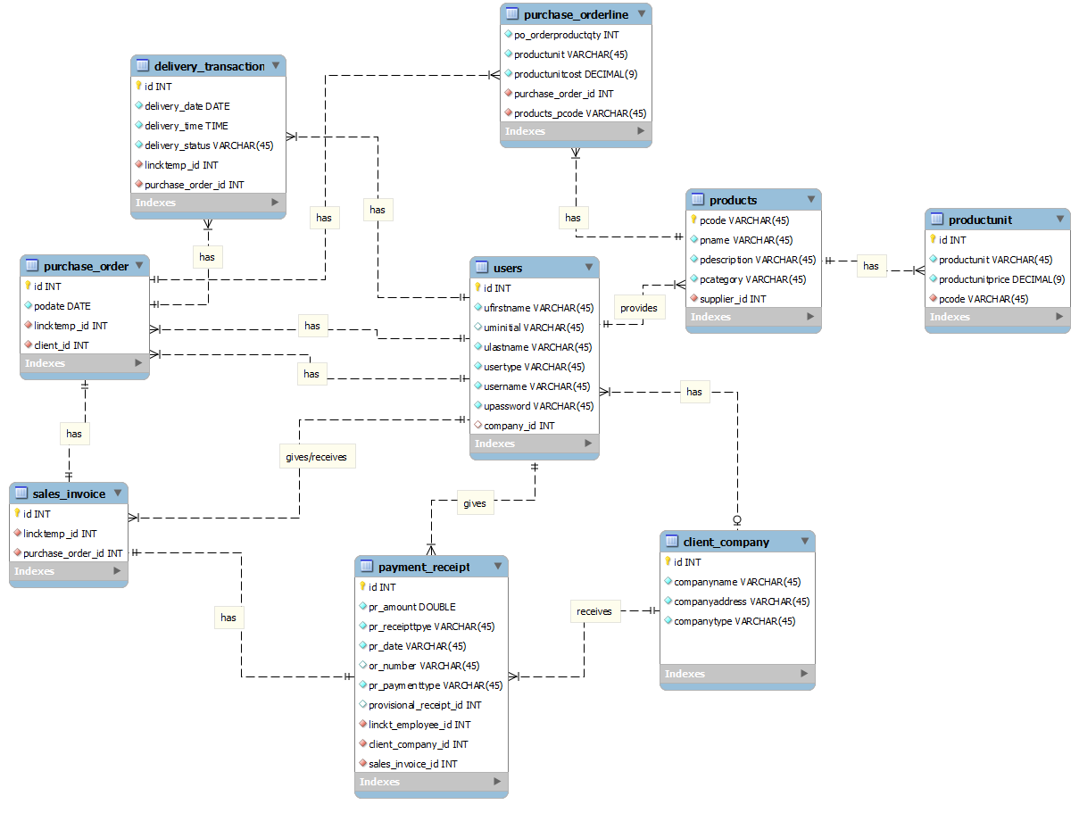

**Data Dictionary**

**client_company**

|  |  |  |  |  |  |
| --- | --- | --- | --- | --- | --- |
| Column | Type | Null | Default | Comments | MIME |
| Company_ID | varchar(45) | No |  |  |  |
| Company_Name | varchar(45) | No |  |  |  |
| Company_Address | varchar(45) | No |  |  |  |

## client_employee

|  |  |  |  |  |  |  |
| --- | --- | --- | --- | --- | --- | --- |
| Column | Type | Null | Default | Links to | Comments | MIME |
| Client_id | varchar(45) | No |  |  |  |  |
| Client_fName | varchar(45) | No |  |  |  |  |
| Client_mInitial | varchar(45) | No |  |  |  |  |
| Client_lName | varchar(45) | No |  |  |  |  |
| Client_ContactNumber | varchar(13) | No |  |  |  |  |
| Client_EmployeePosition | varchar(45) | No |  |  |  |  |
| Client_Company_ID | varchar(45) | No |  | client_company -> Company_ID |  |  |

## company_employee

|  |  |  |  |  |  |
| --- | --- | --- | --- | --- | --- |
| Column | Type | Null | Default | Comments | MIME |
| Employee_ID | varchar(45) | No |  |  |  |
| Employee_fName | varchar(45) | No |  |  |  |
| Empoyee_mInitial | varchar(45) | No |  |  |  |
| Employee_lName | varchar(45) | No |  |  |  |

## delivery_transaction

|  |  |  |  |  |  |  |
| --- | --- | --- | --- | --- | --- | --- |
| Column | Type | Null | Default | Links to | Comments | MIME |
| Delivery_TransactionNum | int(11) | No |  |  |  |  |
| Delivery_Date | date | No |  |  |  |  |
| Delivery_time | time | No |  |  |  |  |
| Delivery_Status | varchar(45) | No |  |  |  |  |
| Company_Employee_ID | varchar(45) | No |  | company_employee -> Employee_ID |  |  |
| Purchase_Order_Purchase_OrderNum | int(11) | No |  | purchase_order -> Purchase_OrderNum |  |  |

## payment_receipt

|  |  |  |  |  |  |  |
| --- | --- | --- | --- | --- | --- | --- |
| Column | Type | Null | Default | Links to | Comments | MIME |
| Payment_ReceiptNum | int(11) | No |  |  |  |  |
| Company_Employee_ID | varchar(45) | No |  | company_employee -> Employee_ID |  |  |
| Payment_Amt | float | No |  |  |  |  |
| Payment_ReceiptType | varchar(45) | No |  |  |  |  |
| Payment_Date | date | No |  |  |  |  |
| Client_Employee_Client_id | varchar(45) | No |  | client_employee -> Client_id |  |  |
| ORnum | varchar(45) | Yes | *NULL* |  |  |  |
| Provisionall_Receipt_Provisionall_ReceiptNum | int(11) | Yes | *NULL* | provisionall_receipt -> Provisionall_ReceiptNum |  |  |
| Payment_Type | varchar(45) | No |  |  |  |  |

## products

|  |  |  |  |  |  |
| --- | --- | --- | --- | --- | --- |
| Column | Type | Null | Default | Comments | MIME |
| ProductID | varchar(45) | No |  |  |  |
| ProductName | varchar(45) | No |  |  |  |
| Product_desc | varchar(45) | No |  |  |  |
| Product_Price | varchar(45) | No |  |  |  |
| Product_Quantity | varchar(45) | No |  |  |  |

## provisional_receipt

|  |  |  |  |  |  |
| --- | --- | --- | --- | --- | --- |
| Column | Type | Null | Default | Comments | MIME |
| Provisional_ReceiptNum | int(11) | No |  |  |  |
| Status | varchar(45) | Yes | *NULL* |  |  |
| PR_Date | varchar(45) | Yes | *NULL* |  |  |
| Check_Date | varchar(45) | Yes | *NULL* |  |  |
| Check_Num | varchar(45) | Yes | *NULL* |  |  |
| Check_Bank | varchar(45) | Yes | *NULL* |  |  |
| Check_BankBranch | varchar(45) | Yes | *NULL* |  |  |

## purchase_order

|  |  |  |  |  |  |  |
| --- | --- | --- | --- | --- | --- | --- |
| Column | Type | Null | Default | Links to | Comments | MIME |
| Purchase_OrderNum | int(11) | No |  |  |  |  |
| Client_Employee | varchar(45) | No |  | client_employee -> Client_id |  |  |
| Purchase_OrderDate | date | No |  |  |  |  |
| Company_Employee_Employee_ID | varchar(45) | No |  | company_employee -> Employee_ID |  |  |

## purchase_orderline

|  |  |  |  |  |  |  |
| --- | --- | --- | --- | --- | --- | --- |
| Column | Type | Null | Default | Links to | Comments | MIME |
| idPurchase_OrderLineNum | int(11) | No |  |  |  |  |
| Purchase_OrderNum | int(11) | No |  | purchase_order -> Purchase_OrderNum |  |  |
| Products_ProductID | varchar(45) | No |  | products -> ProductID |  |  |
| Purchase_OrderProductQty | int(11) | No |  |  |  |  |

## sales_invoice

|  |  |  |  |  |  |  |
| --- | --- | --- | --- | --- | --- | --- |
| Column | Type | Null | Default | Links to | Comments | MIME |
| Sales_InvoiceNum | int(11) | No |  |  |  |  |
| Company_Employee_Employee_ID | varchar(45) | No |  | company_employee -> Employee_ID |  |  |
| Purchase_Order_Purchase_OrderNum | int(11) | No |  | purchase_order -> Purchase_OrderNum |  |  |
| Payment_Receipt_Payment_ReceiptNum | int(11) | No |  | payment_receipt -> Payment_ReceiptNum |  |  |

**VII. Diagrams**

Activity Diagram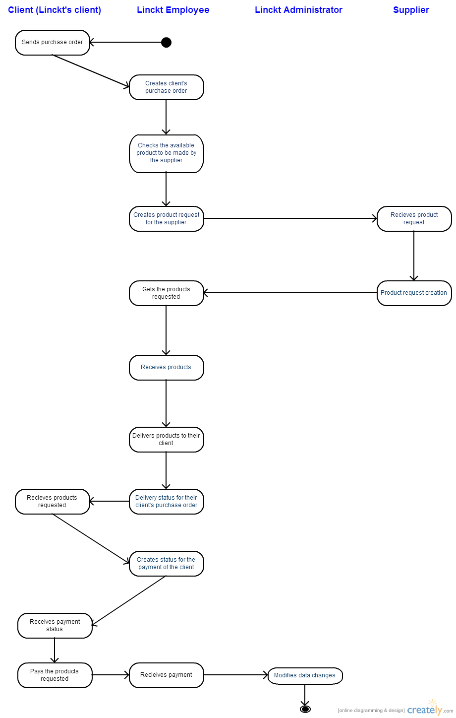

Class Diagram

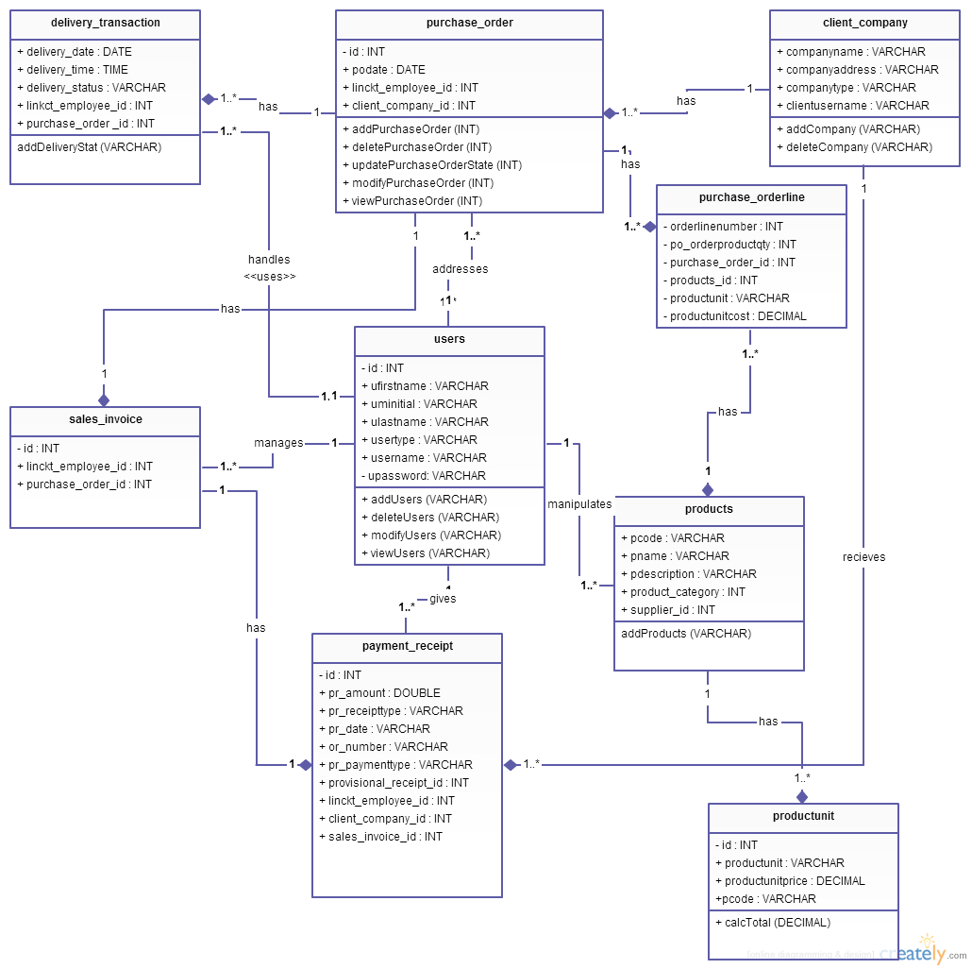

Composite Diagram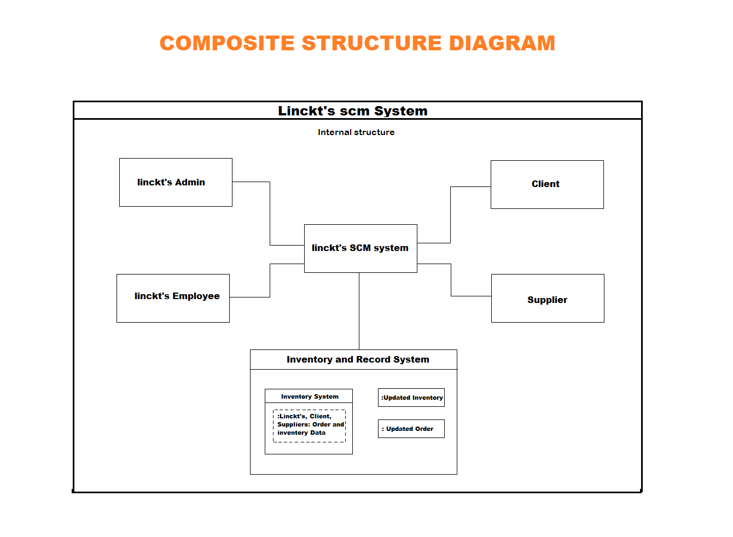State Machine Diagram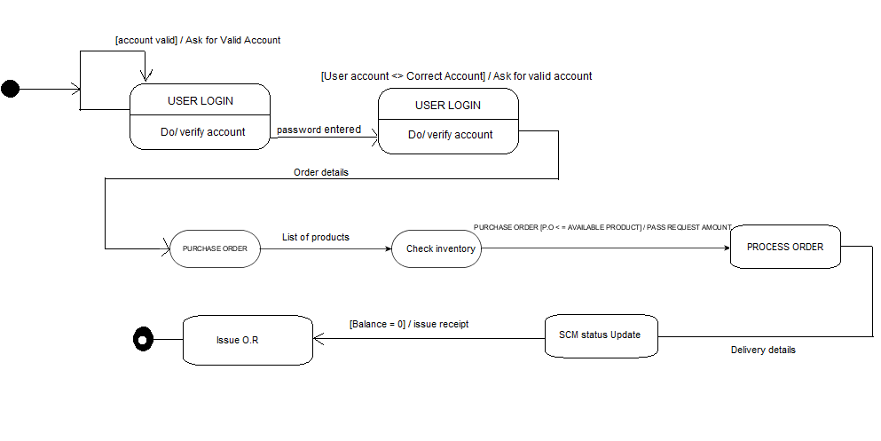

Timing Diagram

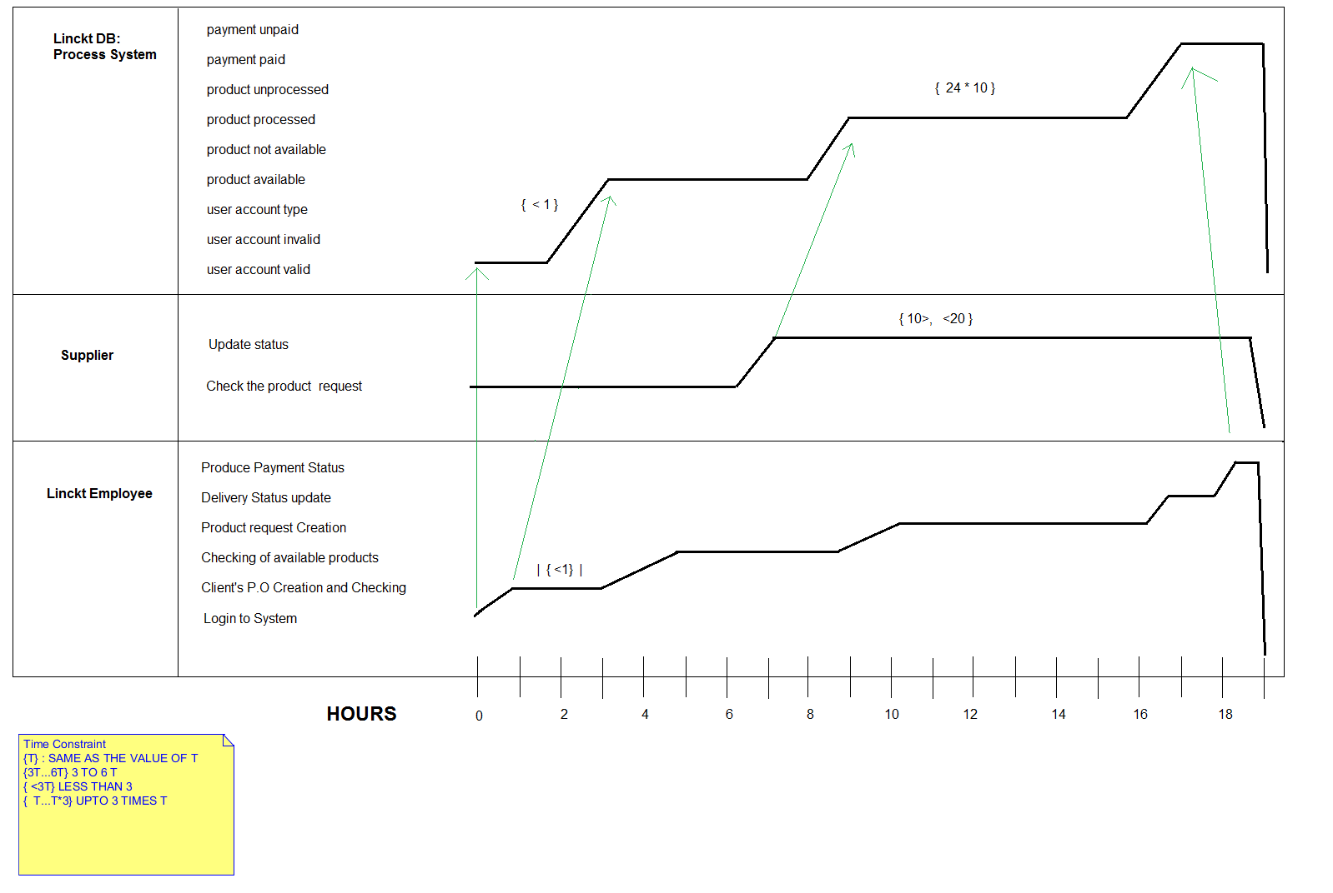

Collaboration Diagram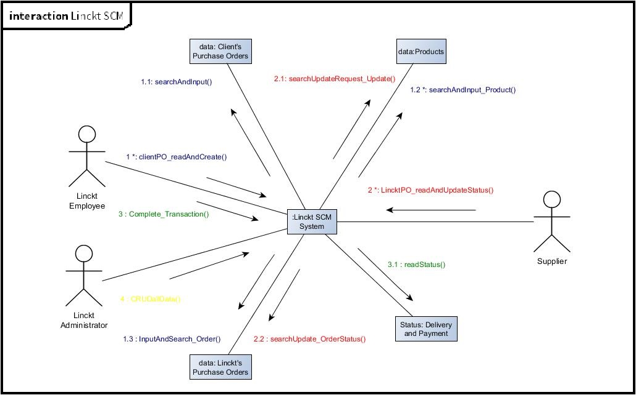

Component Diagram

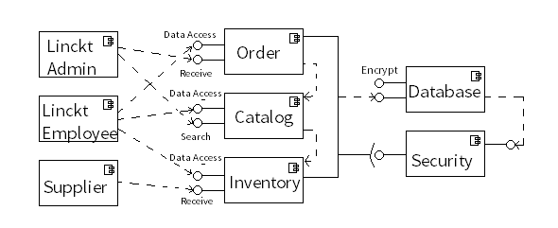

Package Diagram

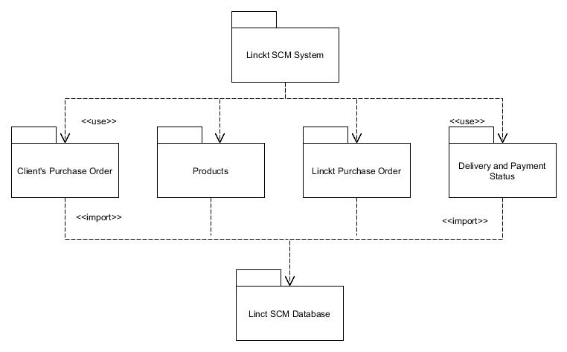

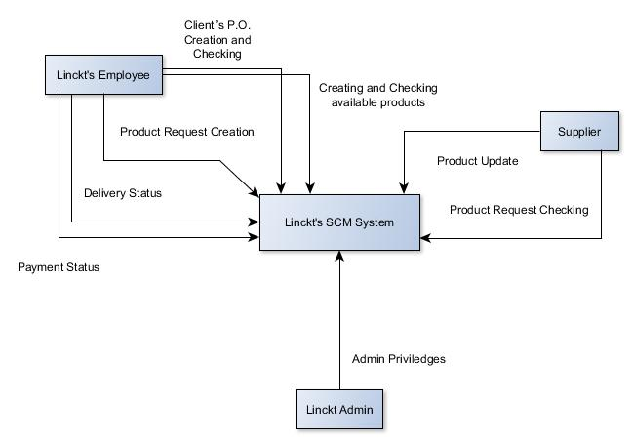Context Flow Diagram

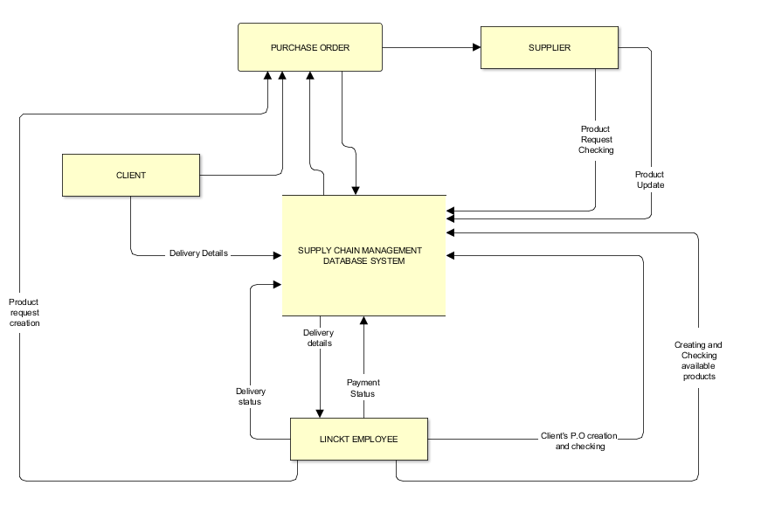Data Flow Diagram

SEQUENCE DIAGRAM

